Julia sets

http://www.mcgoodwin.net/julia/juliajewels.html
http://www.math.lsa.umich.edu/mmss/coursesONLINE/chaos/chaos4/index.html

In the context of complex dynamics, a topic of mathematics, the Julia set and the Fatou set are two complementary sets defined from a function. Informally, the Fatou set of the function consists of values with the property that all nearby values behave similarly under repeated iteration of the function, and the Julia set consists of values such that an arbitrarily small perturbation can cause drastic changes in the sequence of iterated function values. Thus the behavior of the function on the Fatou set is 'regular', while on the Julia set its behavior is 'chaotic'.

Escape velocity algorithm has been used to draw these fractals in matlab.

Common code

Code

The results
M=julia(1,0.285+0.001i,100)
M=julia(1,0.285+0.01i,100)
M=julia(1,-0.70176-0.3842i,100)

Mandelbrot set

Code

The result
mandelbrot(1,100)

Mandelbrot set using z=sin(z) + c

Mandelbrot set using z = z^4+c

Studying the chaotic nature of julia set

Deterministic chaos – pseudo random number generators

Code

The results

Random nature
C=-2 x bw -2 and 2

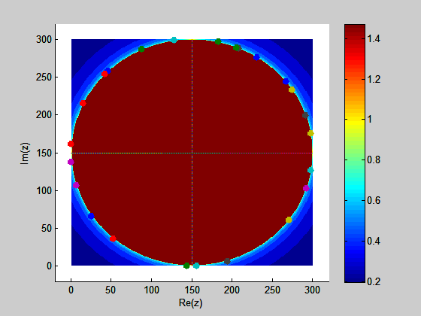

Z0 = cos(theta) + sin(theta)*i; c = 0;

Every time we run the simulation with same parameters, the data I got was exactly the same. This proves that our random number generator is not essentially a unbiased random number generator but in some essence it is deterministic which only appears to be random. This is essentially due to deterministic chaos. These type of random number generators is known as pseudo random number generators.
This illustrates deterministic chaos of Julia sets iterations. Sample size = 100

References
http://aleph0.clarku.edu/~djoyce/julia/julia.html - micromax
http://www.mcgoodwin.net/julia/juliajewels.html
http://home.freeuk.net/alunw/mandelbrotroom.html
http://en.wikipedia.org/wiki/Mandelbrot_set
http://en.wikipedia.org/wiki/Julia_set
http://en.wikipedia.org/wiki/Filled_Julia_set
http://mathworld.wolfram.com/MandelbrotSet.html

